CHEMICAL ENGINEERING TRANSACTIONS  VOL. , 2023 | A publication of
The Italian Association
of Chemical Engineering
Online at www.cetjournal.it

Guest Editors: Sauro Pierucci, Jiří Jaromír Klemeš
Copyright © 2023, AIDIC Servizi S.r.l.
ISBN 978-88-95608-98-3; ISSN 2283-9216

Heat Integration Study of CO₂ Capture in Blue Hydrogen Production
Juliette M. Limpachª, Diego Di Domenico Pinto^{b}, and Hanna K. Knuutila^{a,*}
ªDepartment of Chemical Engineering, Norwegian University of Science and Technology, NO-7491 Trondheim, Norway
^{b}Hovyu B.V., 3118JW Schiedam, The Netherlands
hanna.knuutila@ntnu.no
Hydrogen is an energy carrier that can be used to develop a low-carbon economy: the hydrogen-based industry. For this purpose, a source of hydrogen is needed. Steam methane reforming (SMR) is the current benchmark to produce hydrogen. This technology combines high efficiency and low production cost; however, it is CO₂-intensive. Integrated with carbon capture, SMR could provide a low carbon H₂, (blue Hydrogen). This paper studies the potential of an offshore blue hydrogen production with heat integration allowing recovery of heat in the SMR process to use in the CO₂ capture process. For the studied case, the heat integration shows that almost half of CO₂ can be captured based on chemical absorption with 30wt% MEA. Finally, an economic evaluation discusses the cost of hydrogen production highlighting that CO₂ taxes play a crucial role.
  - Introduction
The effects of climate change are forcing a rapid energy transition. Low- (or no-) carbon energy is required to achieve the climate goals. Although the deployment of renewable energies is increasing fast, a complete change from fossil-based energies is not yet possible. Some critical drawbacks of renewables are intermittent energy/electricity generation and the difficulty of storing their surplus, making a steady energy supply challenging. In this context, hydrogen is seen as a versatile fuel that can be stored and used on demand in many different sectors, including transportation.

Current hydrogen production processes are energy (and carbon) intensive. More than 99% of H₂ is produced from fossil sources against 1% from decarbonized sources (IEA, 2022). Steam-methane reforming (SMR) is state-of-the-art, accounting for 62% of total production (IEA, 2022). To produce low-carbon H₂, CO₂ generated in the process needs to be removed and stored. There are mainly three possible places for installing a carbon capture process in the SMR process: (i) after the water-gas-shift reactors; (ii) at the PSA tail gas; and (iii) at the reformer flue gas. When carbon capture and storage are applied to the SMR process, the produced hydrogen is called Blue H_{2.}

The SMR process is usually a steam exporting process. The process requires energy input in the reformer, which is provided by combusting the natural gas and the PSA tail gas. The flue gas leaving the reformer is still hot (above 1000 °C), and the heat is usually recovered to generate steam. As CO₂ capture is an energy-intensive process, the SMR excess energy could be used to supply its requirements.

This work analyses the heat integration of H₂ production via SMR and the potential for integration with the CO₂ capture process for offshore applications. The Pinch analysis was applied to build the heat exchanger network, and the process costs were calculated.
  - Conventional SMR process (without CCS)

The SMR process comprises three main steps: reforming, water gas shift, and pressure swing adsorption (PSA). The two first steps entail the reaction of methane (and other hydrocarbons) from natural gas with steam to produce hydrogen, carbon monoxide, and carbon dioxide. PSA separate hydrogen from the resulting mixture to obtain a pure product. The global reaction of the SMR process is:
$$CH_{4}+2H_{2}O↔CO_{2}+4H_{2}$$ | (1)
This reaction is divided into two reactions. Reaction 2 (reforming), highly endothermic, comes before Reaction 3, exothermic. Water first reacts with methane at high temperatures in the reformer (furnace is the heat supply). To maximize the H₂ production, the carbon monoxide leaving the reformer further reacts with remaining water at lower temperature(s). Usually, reaction 3 takes place in two series reactors. The first one at high temperatures to favor better kinetics, and the second one at low temperatures to favor the equilibrium toward hydrogen production. The kinetics of the reactions are described, for instance, by Xu and Froment (1989).
$$CH_{4}+H_{2}O ↔ CO+3H_{2}$$  $$CO+H_{2}O ↔ CO_{2}+H_{2}$$ |  | (2)  (3)

    - Modelling
A SMR plant with a production of 130 MSft³/d is modelled in Aspen Plus software version 12.1. The Peng-Robinson Equation of State is chosen to model the system thermodynamics. Each reactor is modelled with the equilibrium Gibbs (RGIBBS) reactor. The process feed consists of water and methane. In this work, natural gas is composed of pure methane. Before entering the reformer, feed streams are compressed at 2604 kPa and heated to 600 °C. The exiting stream of the reformer, set to 875°C, is cooled down to 350 °C before it enters the high-temperature shift reactor (HTS). The stream leaving the HTS is further cooled down to 200 °C before entering the low-temperature shift reactor (LTS). The resulting stream is further cooled down to 35°C prior to entering the PSA, where most water is condensed and recycled to the inlet of the reformer. The PSA is a dynamic process consisting of several columns operating at high- and low-pressure levels. In this work, steady-state modelling in Aspen was used and the PSA is modelled as a simple component splitter with a hydrogen split fraction of 0.99. The tail gas leaving the PSA enters the combustor (modelled as an RGIBBS reactor) together with an air stream and additional natural gas. In reality, reforming and combustion (heat transfer) take place in the same equipment (i.e., the reformer). However, it is not possible to model a reformer directly in Aspen, so two reactors are used where the reformer uses the energy provided by the combustor. The PSA tail gas and the air are pre-heated before entering the furnace. The flue gas is set to leave the furnace at 1000 °C and is sent to a heat recovery step. Figure 2 shows the simplified process flowsheet.
  - First results and Pinch analysis
The flue gas is the biggest source of heat in the SMR process. Traditionally, heat recovery is applied to generate steam to export as additional revenue to the plant. To produce 130 MSft³/d of H₂, 129 MW is required by the reformer, while 111 MW could be recovered from the flue gas (assuming cooling it down to 150 ˚C). The recovered heat from the flue gas is intended to be used by the CO₂ capture plant to produce blue H₂. For this purpose, heat integration is performed to minimize external energy requirements and to optimize where the available heat is used.

Heat integration maximizes energy saving by crossing hot and cold flows to recover heat. For this purpose, the so-called Pinch analysis can be performed. It consists of determining the Pinch point and the energy targets of a process. The Pinch point divides the process into two parts: a heat sink above the pinch and a heat source below. In the heat sink, only heat can be supplied (hot utilities), while below, only cooling is allowed (cold utilities). The results are best represented graphically using the Grand Composite Curve (GCC). The GCC represents the evolution of temperature as a function of the stream's differential enthalpy. Figure 1a shows the GCC of the SMR plant where the shifted temperatures are represented. A minimum temperature of 10°C between hot and cold streams is considered. In this study, the maximum shifted temperature (1856.41°C) is the pinch point, i.e., no external heat supply is needed, only a cold supply. The cooling requirement is 89 MW.

The next step is to design the heat exchanger network for the process. This network is built by considering the capacity and temperature of each stream used for the pinch analysis. Figure 1b shows the heat exchanger network consisting of seven heat exchangers and two coolers.

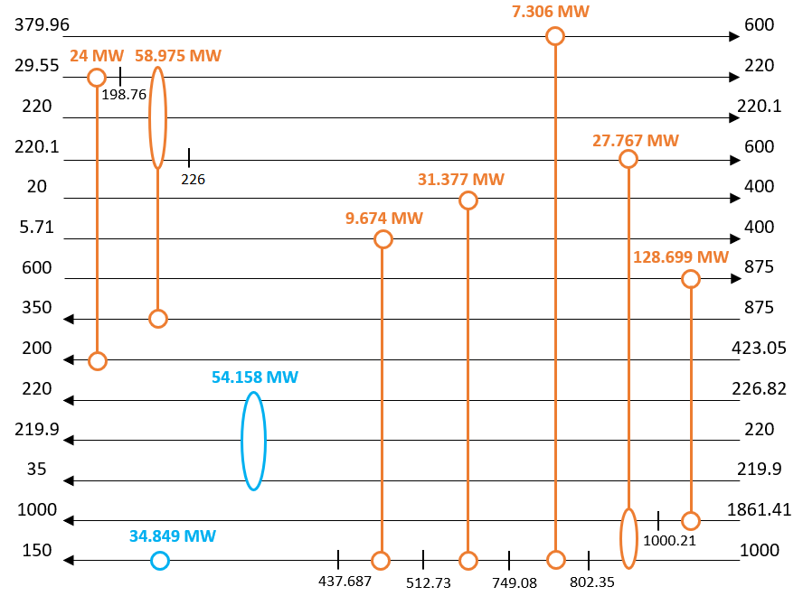
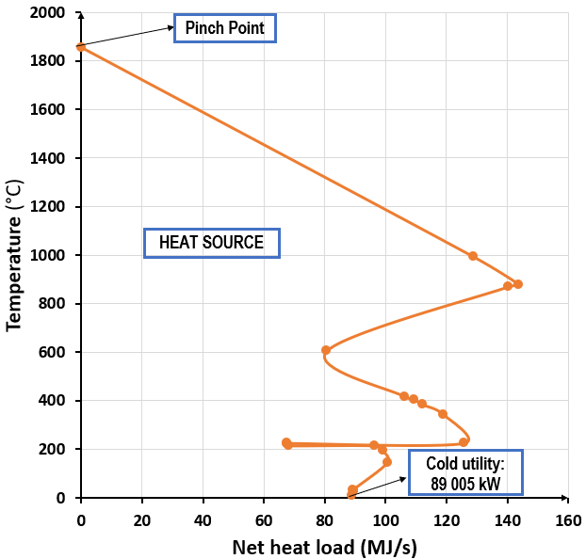
a) GCC b) Heat exchanger network
Figure 1: Pinch Analysis

The Pinch analysis also helps to illustrate the amount of heat available for the needs of CO2 capture. In this study, 30 wt% MEA is used as a solvent, and the solvent is regenerated at temperatures around 120 °C. This means that steam above 125 °C is needed. For these purposes, saturated steam is produced at 135 °C. This means that only part of the heat available in the stream leaving the low temperature water gas shift reactor can be utilized. Thus, only 55.6 MW in these streams is available for regeneration of the CO2 capture solvent. As the PSA operates at the temperature of 35 °C, two heat exchangers (Figure 2) are needed in this part. The steam cycle addition leads to a final cold utility of 33.4 MW.

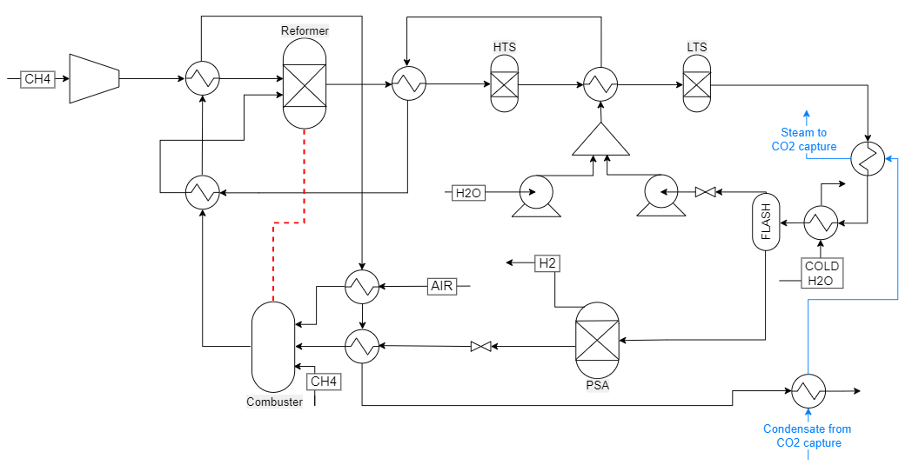
Figure 2: Final SMR flowsheet after heat integration

The final flowsheet of the process is shown in Figure 2. With the addition of the steam generation cycle, the heat exchanger network is composed by nine heat exchangers. The flue gas passes through a total of five heat exchangers providing the remaining energy to heat up the combustion chamber and reformer feed streams, as well as the steam cycle. Two HTX are added before the flash: the first provides the final energy to generate steam for CO2 capture and the second provides the remaining cooling energy.

The main goal of this heat integration is to minimize the need for external heat required in the carbon capture process. In this study, an amount of 111.386 t_{CO2}/h is produced. The energy requirement, for post-combustion capture, of a chemical absorption process using aqueous 30 wt.% monoethanolamine (MEA) as a solvent ranges between 3.2 and 4.2 GJ/t_{CO2} (Meihong et al., 2015). This translates into an energy requirement between 100 and 130 MW to capture all CO₂ produced. However, only 55.6 MJ/s is recovered with the steam cycle at temperatures above 125°C. As a result, about half of the CO₂ could be captured without the addition of extra energy input. By changing the operating parameters of the SMR and combusting more natural gas in the reformer, the steam required to remove CO₂ can be fulfilled. The most advanced solvents promise reboiler duty energy down to 2.2-2.5 GJ/t_{CO2} (Rochelle, 2016), potentially allowing 70 to 80% of produced CO₂ to be captured with available heat.
  - Cost analysis
One of the major costs of the CO₂ capture process is its associated energy requirements. Thus, applying CO₂ capture to H₂ production will inevitably increase the production costs. An economic analysis is performed to identify the impacts of implementing a blue H₂ process. The methodology shown in Turton et al. (2018) is used to calculate the capital (CAPEX) and operating (OPEX) expenditures of the heat-integrated process.
Figure 3 presents the capital expenditure of each part of the process without CO₂ capture. To derive these costs, some assumptions were considered. When volume data is required, it was calculated using the outlet flow rate of the respective unit and assuming a residence time of 10 minutes for the liquid phase or 1 minute for the gaseous phase. Heat exchangers’ surface areas were calculated with Eq. 4:
$$Q=U⋅A⋅F⋅∆Tlm$$ | (4)
Where Q is the duty [kW], U is the heat transfer coefficient [kW/(m²K)], F is the correction factor [-] and ΔTlm is the logarithmic mean temperature difference [K]. A total of 90 M$ is calculated for the CAPEX. The reformer unit is the main contributor to the expenses, contributing approximately to 60% of the total costs.
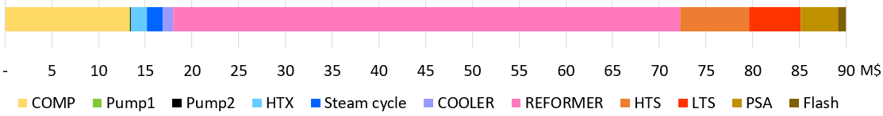
Figure 3: CAPEX of the SMR
The operational and maintenance costs are then evaluated. They include the fixed capital investment (FCI), the cost of direct labor (COL), utilities (CUT), waste treatment (CWT), raw materials (CRM), and depreciation (d). For the calculations, plant lifetime is assumed 10 years, and most of the goods are supplied by Norway or the United States. Methane price of 7.4 $/Mft³ (EIA, 2022), water price of 0.05 $/m³ (Intratec, 2022) and cooling water price of 0.378 $/GJ (Turton et al., 2018) are considered. Grid electricity is evaluated at 0.14 $/kWh (GlobalPetrolPrices.com, 2022), and the average salary of a chemical operator is 45 k$/y in Norway (Salaryexplorer, 2022). Also, carbon taxes are included and estimated at 87.61 $/t_{CO2} (Tax foundation, 2022). Table 1 presents the results for the OPEX cost per year. COMd is the total cost of manufacturing without depreciation:
$$COMd=0.18FCI+2.73COL+1.23⋅\left(CUT+CWT+CRM\right)$$ | (5)
Table 1: OPEX Cost
FCI  M$ | COL  k$/y | CUT  M$/y | CWT  M$/y | CRM  M$/y | D  M$/y | COMd  M$/y
90 | 672 | 29 | 82 | 166 | 13 | 368

Considering a stream factor of 0.96 (Turton et al., 2018), the annual production of hydrogen is 11t resulting in a hydrogen production cost of 3.26 $/kg H₂ without depreciation (3.38$/kg with depreciation). Figure 4a shows the hydrogen production costs distribution. It can be directly seen that raw materials costs have the higher contribution (57%). Indeed, natural gas (methane) price is the main expense of the process. Following the raw materials, carbon taxes costs (CWT) have the second most significant impact, almost 30% of the total cost. In comparison, other expenses like electricity or capital costs have a low contribution.

As a comparison, Figure 4b shows the contributions without implementing carbon taxes. Without taxes, raw materials cost contribution increases from 57% to 80% of total costs, and the hydrogen production cost reduces to 2.34$/kg without depreciation (2.46$/kg with depreciation). The cost is reduced by almost 30% compared to the case where carbon taxes are implemented. Figure 4 directly shows the strong effect of carbon taxes in the implementation of blue hydrogen production. Carbon taxes are expected to increase over the years, and the higher the CO₂ taxes, the higher the hydrogen production cost. Eventually, the costs of capturing and storing CO₂ will be lower than the taxes paid to emit CO₂, making it a positive business case to implement such processes. Previous investigations showed that implementing CO₂ capture in SMR process increases the H₂ production costs to 1 to 2 $/kg_{H2} (IAE, 2021) Therefore, if carbon taxes continue to rise, it may be economically beneficial to implement CCS in SMR processes.
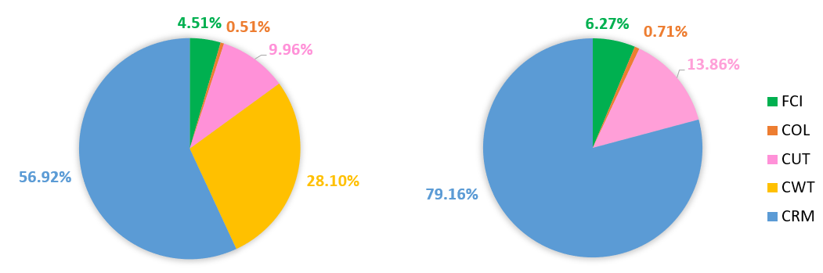
a) with carbon taxes b) without carbon taxes
Figure 4: Cost breakdown of hydrogen production

In this work, the SMR process is estimated to produce H₂ at a price of 3.26 $/kg_{H2} with carbon taxes and 2.34 $/kg_{H2} without it. Different costs for hydrogen production are given in literature. Each of them is based on different assumptions like the costs of utilities, plant lifetime, choice of the interest rate of return, the capacity of production and even the operating conditions of the process. Therefore, comparing two sources is sometimes not directly possible, especially since many of the published work study improved and alternative SMR processes to increase its efficiency.

Literature provides a cost range between 2 and 6$ per kg H₂ for the SMR production depending on the price of natural gas (SGH2, 2022). More specifically, Idaho National lab (INL) evaluated the price of hydrogen product for an IRR of 15% with a plant capacity of 130 MSft3/d between 2.49 and 3.72$/kg_{H2} for high natural gas and carbon taxes cost (INL, 2010). In this work, for an IRR of 15% and a plant lifetime of 30 years (same condition as the INL report) the product selling price of hydrogen is evaluated at 2.87 $/kg_{H2}. Although the results cannot be directly compared, the costs presented in this work lie very close to the ones reported in the literature.

Moreover, Hydrogen Europe (2022), published data showing a considerable increase in grey hydrogen prices during these past years resulting from the variation in raw material prices. The prices of the grey hydrogen production were estimated in the ranges 1.4 and 1.8 €/kg_{H2} from 2018 to 2020 while in 2021 it increased to 2.65 €/kg_{H2} (Hydrogen Europe, 2022). In this work, the same effect appears; hydrogen production price is further increase to 3.26 $/kg_{H2} because of natural gas price and carbon taxes.
  - Conclusion
A study on the heat integration of the steam methane reforming has been performed considering the need for steam for chemical absorption-based CO₂ capture plant.With energy recovered from the SMR process, it is possible to capture almost half of the CO₂ produced (using 30 wt.% MEA as the solvent). The economic analysis of the process shows that with the increase of carbon taxes, CO₂ capture costs can potentially become competitive. In 2022, the carbon taxes were already accounting for 30% of the production cost of hydrogen. In several countries, carbon taxes are expected to increase over the years. As a result, switching technology to low-carbon processes by implementing CO₂ capture on SMR will potentially present a positive business case. Performing heat integration to reduce external energy requirements while using the best technology can help in the transition to the low low-carbon industry, especially the hydrogen industry. Combining this with an offshore plant that allows for direct storage of the captured CO₂ capture without major transporting costs could also significantly reduce low carbon hydrogen production costs.

Acknowledgements
This work was carried out as a part of SUBPRO (Subsea Production and Processing), a Research-based Innovation Centre within Subsea Production and Processing. It is funded by major industry partners, the Norwegian University of Science and Technology (NTNU) and the Research Council of Norway (RCN) [project number 237893].

References
EIA, 2022, United States Natural Gas Industrial Price, <www.eia.gov/dnav/ng/hist/n3035us3m.htm> accessed 14.01.2023.
GlobalPetrolPrices.com, 2022, Electricity prices, <www.globalpetrolprices.com/electricity_prices/> accessed 5.01.2023.
Hydrogen Europe, 2022, Clean Hydrogen Monitor edition 2022, <hydrogeneurope.eu/clean-hydrogen-monitor-2022/> accessed 10.01.2023.
IEA, 2022, Global Hydrogen Review 2022, <iea.blob.core.windows.net/assets/c5bc75b1-9e4d-460d-9056-6e8e626a11c4/GlobalHydrogenReview2022.pdf> accessed 18.12.2022.
IEA, 2021, Global Hydrogen Review 2021 Executive Summary, <www.iea.org/reports/global-hydrogen-review-2021/executive-summary > accessed 30.01.2023.
INL, 2010, HTGR-Integrated Hydrogen Production via Steam Methane Reforming (SMR) Economic Analysis, U.S. Department of Energy, Document ID: TEV-954
Intratec, 2022, Cooling water costs, <www.intratec.us/products/water-utility-costs/commodity/cooling-water-cost > accessed 24.01.2023
Meihong W., Atuman S. J., Colin R., Dag E., Nuhu M. M., 2015, Process intensification for post-combustion CO2 capture with chemical absorption: A critical review, Applied Energy 158, 275–291.
Rochelle G.T., 2016, Conventional amine scrubbing for CO2 capture, Elsevier Inc., 35-67
Salaryexplorer, 2022, Power plant operator average salary in Norway 2022, <www.salaryexplorer.com/salary-survey.php?loc=162&loctype=1&job=12599&jobtype=3> accessed 28.12.2022.
SG H2 Energy, 2023, Economics-cost comparison, <www.sgh2energy.com/economics/#econheader > accessed 30.01.2023
Tax foundation, 2022, Carbon taxes in Europe, <taxfoundation.org/carbon-taxes-in-europe-2022/> accessed 5.01.2023.
Turton R., Shaeiwitz A. J., Bhattacharyya D., Whiting B. W., 2018, Analysis, Synthesis and Design of Chemical Processes, Fifth Edition, Pearson Education, Inc., ISBN: 9780134177403.
Xu G. J, Froment F.G., 1989, Methane steam reforming, methanation and water–gas shift: I.Intrinsic kinetics, AICHE J. 35, 88–96.

